**Waypoint-Editor**

**Intro to C# Assignment one**

**By Adam Whitty**

Contents

**Contents2**

**Summary3**

**Screen Mock-Ups3**

Main Window3

Dialogues 4

Error Pop Up 4

**State Diagram5**

**Save File Format6**

**Summary:**

This document details the proposed design elements for a new way point editing tool to assist in game development.

This tool will allow the user to plot waypoints by clicking on an imported 2D map (Map Will Work via drag and drop on the waypoint window) then connect them.

The program will be able to save all way points and connections data will be saved in a text file.

**Screen Mock-ups:**

**Main Window**

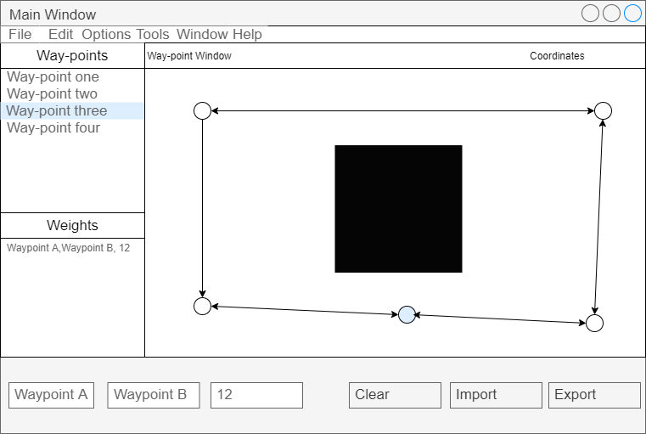

Figure 1. Shows the Main Window for the Waypoint Editing tool

The Mock-up shown in figure one is the main window for the tool.

Points can be placed inside the way point window by clicking on a position inside the window. Way points can also be selected by clicking directly on them inside the window or by selecting it from the tab on the left which shows all placed waypoints and connections. Mouse coordinates will be shown in the bottom window while the mouse is over the Waypoint window. Placed Waypoints will be able to be moved using a click, drag, and drop process.

Connections will be added by holding shift and clicking on the two waypoints that will be connected upon releasing the shift key.

**Dialogues:**

Saving and Loading dialogue boxes are displayed when the user selects the save or load options from the drop-down file menu.

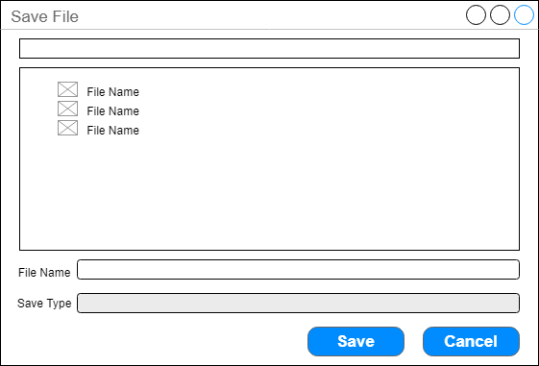

Figure 2. The Save Dialogue box

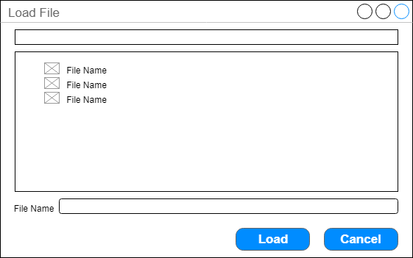

Figure 3. The Load Dialogue Box

If the user tries to load a file that is the incorrect format or has become corrupted, the Error dialogue box shown in Figure 4 will be displayed.

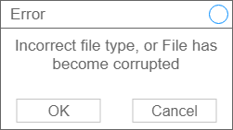

Figure 4. Error Dialogue Box

**State Diagram:**

The state diagram shown in figure 5. Shows the various states and how the program transitions between them. The user will spend most of their time in a wait for input state where the program is waiting for the player to click on the Waypoint window. Other transitions include a save data state and a load data state, as shown.

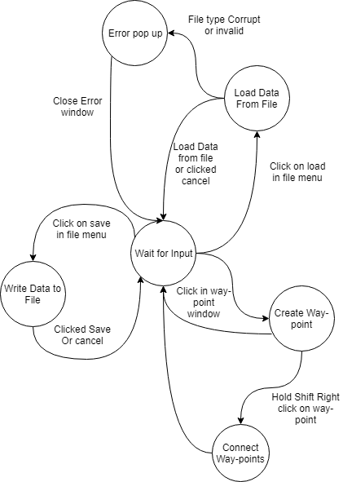

Figure 5. State Diagram

**Save Data Format:**

The save data format will be csv (comma separated values).

The information saved in the document (see figure 6.) will be the name of the point, the X,Y coordinates of the points and the X,Y of the length of the connection along with a string of metadata containing information the user may need for use in other programs.

Point name, 12,14,” v = 18, int = 12, other needed information”, connection name, 13

Point name, 42,12,” v = 18, int = 12, other needed information”, connection name, 15

Figure 6. Save file example